**TravelBlogWebsite**

**WEBPROJECT(1) FWD291**

**Full Stack Web Developer**

**Supervisor:Dr.EmanMuhammadAl-Jawadi**

**Presented by:**

**BushraAbdulRahmanAl-Rahili**

**4455439**

**HanadiSaadAl-Rashidi4455726**

**DanaAbdullahAl-Wasabi 4456121**

**RawabimunawarAl-Rashidi4470256**

**RimaIbrahimAl-Harbi4454162**

**AcademicYear1445AH**

**Acknowledgement**

##### Wethank theacademicstaffatthecollegeWeexpress ourheartilygratitudeto ourfamiliesandfriendsfortheirsupportencouragementandwishes.Wesayspecial thanks tooursupervisorDr.Eman MuhammadMukhtarAl-Jawadiforguidanceat every step and encouragement throughout the project

**Abstract**

##### Tourismservesasavitalcornerstoneofanycountry'seconomy,bearingwitnesstoits civilization and values. It has come to our attention that both domestic and international tourists often encounter challenges in planning their trips to the Saudi Arabia, lacking accessible resources to assist them. Consequently, obtaining informationabouttourisminSaudiArabiacanbetime-consumingandcumbersome. That's why we conducted this survey—to ascertain the existence of an issue. Our findingsrevealedthatamajorityofindividualsstruggletoplantheirtripswithoutthe assistance of a tour guide.

##### Thisleadsustoourproposal,a“blogtravelfortheKingdomofSaudiArabia”aimed at addressing this issue. Such a platform would assist individuals in efficiently planning their trips, thereby saving them time and effort. Additionally, it would broadentheirunderstandingofSaudiArabia,showcasingnotonlyitsrenownedsites like Mecca and Medina but also its diverse array of entertainment, archaeological, and educational attractions.

**ListofTables**

Table2.1:Comparativetableofwebsitesforblogtravel 15

**ListofFigures**

FIGURE1.1:PROJECTTIMELINE 10

Figure2.1:TheprincipalpageofwebsiteThedollzter 11

Figure2.2:Theprincipalpage ofwebsiteTravelBlog.com 12

Figure2.3:TheprincipalpageofwebsiteWanderlust's 13

Figure2.4:Theprincipalpage ofwebsiteTravel hero 14

Figure3.1:Usescase diagramforAdmin 18

Figure3.2:usescasediagramforUser 20

Figure3.3:Flow Chartofourwebsite 20

Figure3.4:AdvancedWaterfallmodel 21

Figure4.1:ClassDiagram 22

Figure4.2:Sequence DiagramforviewBlog 23

Figure4.3:Sequencediagramforcreateaccount 24

TableofContent

Contents

**ACKNOWLEDGEMENT 2**

**ABSTRACT 3**

**LISTOFTABLES 4**

**LISTOFFIGURES 5**

**TABLEOFCONTENT 6**

**CHAPTER1:INTRODUCTION 8**

* 1. Introduction 8
  2. ProblemDefinition 8
  3. ProjectObjectives 8
  4. ProjectScope 9
  5. ProjectTimeline 10
  6. DocumentOrganization 10

**CHAPTER2:LITERATUREREVIEW 11**

* 1. INTRODUCTION 11
  2. RelatedworkandSimilarSystems 11
  3. Synthesisand discussion 14

2.3 Summary 15

**CHAPTER3:PROJECTREQUIREMENTSANDSYSTEMANALYSIS 16**

* 1. Introduction 16
  2. Requirements 16
     1. *FunctionalRequirements 16*
     2. *Non-FunctionalRequirements 17*
  3. SYSTEMANALYSIS 18
     1. *UseCaseDiagram 18*
     2. *Flow Chart 19*
  4. DevelopmentMethodology 20
  5. SUMMARY 21

**CHAPTER 4:SYSTEM DESIGN 22**

* 1. Introduction 22
  2. ObjectOrientedDesign 22
     1. ClassDiagram 22
     2. SequenceDiagram 23

REFERENCES 25

**Chapter1:Introduction**

* 1. **Introduction**

Traveling serves as a significant form of entertainment for many individuals. Exploring new destinations, experiencing diverse cultures, and learning about civilizations are all integral parts of this experience. As Saudis, we hold a particular passion for travel. Our region boasts remarkable diversity; the North differs from the South, and the East varies from the West. Moreover, each region possesses its unique climate and terrain, adding to the richness of our travel experiences.

* 1. **Problem Definition**

Tourists and residents face several challenges when searching for tourist destinations in SaudiArabia. These difficulties stemfromalack of guidanceregarding thebestproducts, foods, hotels, and tourist attractions. Overall, there is a prevalent issue in Saudi Arabia regardingthedifficultyofintroducingtouriststonewculturesandefficientlyguidingthem to destinations in a concise, helpful, and reliable manner.

In recent years, with the advent of the Internet and mobile phone networks, numerous mobile applications and websites have emerged to assist tourists in the Kingdom of Saudi Arabia. However, most of these electronic solutions fail to fully meet the requirements of travelers. Among the technical solutions that developers should provide to alleviate these challenges is the availability of websites offering a wide range of products, foods, and tourist destinations. These websites should provide comprehensive information about various places that users can search through, including evaluations and prices, ultimately enhancing the overall travel experience in Saudi Arabia.

* 1. **ProjectObjectives**

Ourobjectives inthis projectaretocreateawebsitethatcan:

1. **ProvidingaReliableSource**:Theblogaimstobeatrustedsourcefortravelersseeking information about cities and places visited by others.Visitors can rely on the information providedby othertravelers,as theydescribetheirpersonalexperiences,observations,and explorations of places.
2. **Sharing Experiences and Knowledge:** Different travelers can exchange their experiences andknowledgethroughtheblog.Tips maybeoffered,favoriteplaces shared, and fun activities recommended in various cities. New travelers can benefit from this information to enhance their personal experience and plan their future trips.
3. **Communication and:** The project works on enhancing direct communication among travelers.BalancePeopleinterestedinvisitingspecificplacescanconnectwiththosewho havealreadyvisitedthem.Former travelerscanprovideadvice,guidance,and answerany questions that new visitors may have.
4. **EncouragingExplorationandAdventure**:Theblogcaninspirereaderstoexploreand discover new places. Articles and personal experiences can showcase the spirit of adventure, different cultures, and amazing tourist attractions awaiting visitors around the world**.**
5. **Building an Online Community:** The project can contribute to building an online communityfortravelersandtravelenthusiasts.Thiscommunitycanserveasaplatformfor sharing, collaboration, and exchanging ideas and experiences in the field of travel and tourism.
   1. **ProjectScope**

We aim to create a blog for individuals who travel the world and wish to share their experiences and discoveries from the places they have visited. They will have the opportunity to write articles about the cities, tourist attractions, activities, and restaurants they have enjoyed. Additionally, they can offer ideas and tips for those who plan to visit theseplaces.Readerswillbeabletointeractwiththeauthorsbyaskingquestionsorseeking advice.Thisplatformseemslikeitwillbebeneficialformanyindividualsseekingauthentic experiences and practical information before embarking on their travels.

We also aim to promote global culture and broaden people's horizons by exploring and learning about new places.

* 1. **ProjectTimeline**

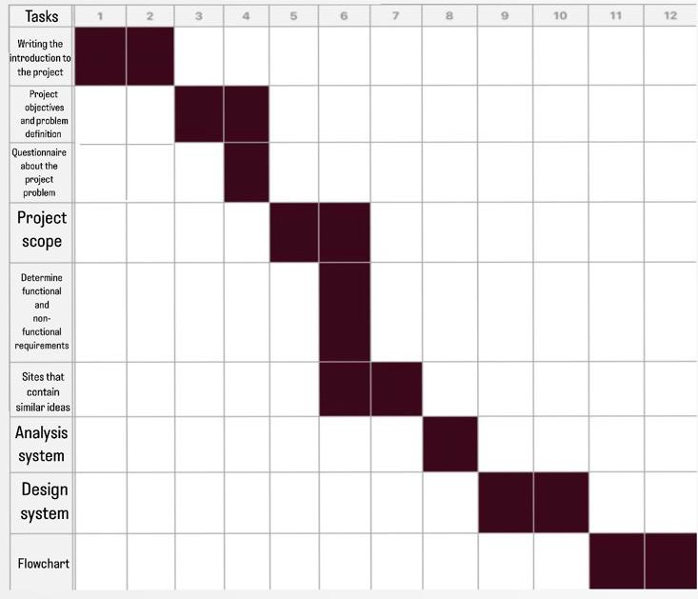

**Figure1.1: Project timeline**

* 1. **DocumentOrganization**

The remainder of this document is organized as follows: Chapter 2 will analyze existing websites that serve travel bloggers. In Chapter 3 we will present the system analysis process, which aids in studying the site and its components, and defining its goals. In Chapter 4, we will design our system using class and sequence diagrams, as well as designing some user interfaces for our website.

**Chapter2:LiteratureReview**

* 1. **Introduction**

In this chapter, we will evaluate various websites that cater to travel bloggers. We will provide descriptions and analyze the features of each site to capitalize on their strengths and mitigate their weaknesses in the development of our system

* 1. **RelatedworkandSimilarSystems**

In this section, we will showcase some of the best travel blog websites that have been developed in the past to cater to people interested in tourism**.**

#### Thedollzter

ThewebsiteThedollzter**[1]**isownedbyDollzandprimarilyfeaturesherpersonaljourney, traveltips,travelreviews,andtravel-relatedsocialmediacontent.Thiswebsiteallowsusers toaccessfrequentlyaskedquestionsandviewphotosoftheplacesvisitedbyDollz(Figure 2.1).

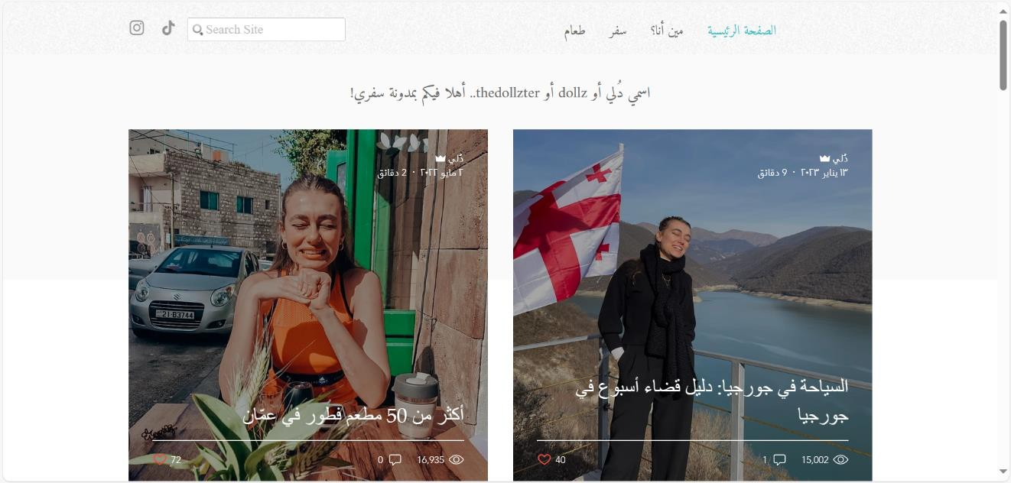

**Figure2.1: TheprincipalpageofwebsiteThedollzter**

##### Disadvantagesof Thedollzter

Itdoesnotallowuserstoviewotherpeople'sopinionsabouttheblogor their travels.

Itdoesnotenableuserstosharetheiropinionsabouttheirtravels.

Itdoes notprovideinformationonpricesinmostareas.

Itdoes notclarifywhethertheseareas aresafeforfamilies ornot.

#### TravelBlog.com

The website travel Blog.com**[2]** provides information about the most renowned touristcities and highlights the essential hotels for a pleasant and comfortable stay (Figure 2.2).

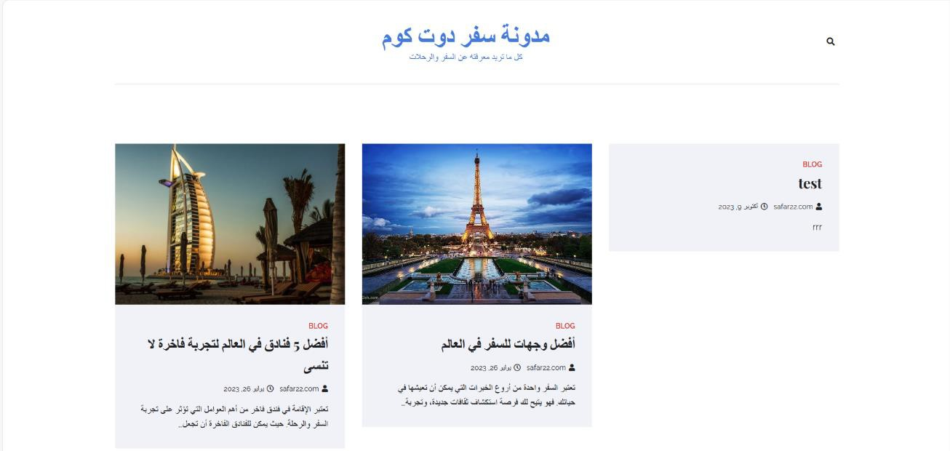

**Figure 2.2: Theprincipalpage of websiteTravelBlog.com**

##### DisadvantagesofTravelBlog.com

Itlacksinformationontravellogisticsandsafetyconsiderations.

Userscannotviewothers'opinionsaboutthis blog.

Itprovidesonlybriefdescriptions oftheareasandaccommodations.

Itdoes notincludepicturesofthetourist cities discussed.

#### Wanderlust's

The website Wanderlust's **[3]** is Charli's travel blog, where she provides tips and informationabouthertravels,alongwithsharingherpersonalexperiences.Onthiswebsite, Charlirespondstoalluserinquiries,interactswithusers,andprovidesdetailedaccountsof theplacesshevisits.Wanderlust'salsoallowsuserstoviewpicturesandsomevideosfrom each of Charli's trips (Figure 2.3).

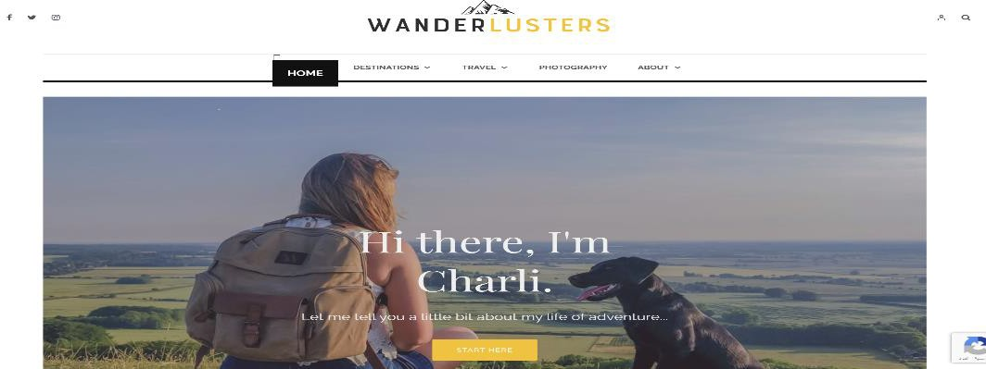

**Figure2.3: TheprincipalpageofwebsiteWanderlust's**

##### DisadvantagesofWanaderlust's:

Theuserisunabletoaccessinformationregardingcostsandbudgetfor certain places

Theusercannotsharetheirexperience;Charlionly speaksfromherown experience**.**

### Travelhero:

The website **Travel hero** [4] is the first interactive travel guide that allows users to customizetheirtripsbasedontheirmoodandbudgetwiththeassistanceof travelexperts. It enables the user to discuss restaurants, hotels, and potential activities, as well as to upload photos and videos (Figure 2.4).

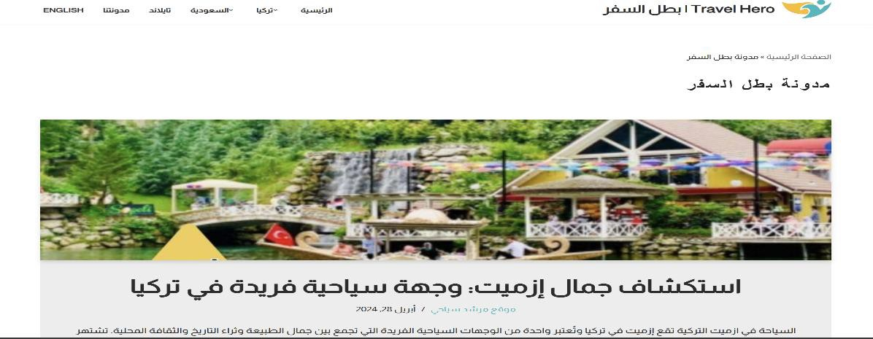

**Figure 2.4: Theprincipalpage of websiteTravelhero**

##### DisadvantagesofTravelhero:

Theusercannotcommentonblogs.

Thewebsitedoesn'tprovideenoughadvicefortravelers.

* 1. **Synthesisanddiscussion**

Weconductedacomparativeanalysisofothersitesbasedontheobjectivesdescribed in the introduction (Table 2.1).

Based on Table 2.1, we can conclude that some characteristics have considered by allor some websites, such as encouraging exchanging experiences and knowledge, providing reliablesources and quickly search. Other characteristics, such as contains travel in Saudi Arabia, thatbeen taken into account only by Travel Hero website.

**Table2.1:Comparative tableofwebsitesfor blog travel**

|  |  |  |  |  |
| --- | --- | --- | --- | --- |
| **feature** | **Thedollzter** | **Travel Blog.com** | **Wanderlust's** | **Travelhero** |
| **Providing a Reliablesource** | + | _ | _ | + |
| **Sharing Experiences**  **and Knowledge** | _ | _ | _ | _ |
| **Communication and Balance** | _ | _ | _ | _ |
| **Encouraging Exploration andAdventure** | + | + | + | + |
| **Buildingan Online Community** | _ | _ | _ | _ |
| **Contains travel inSaudiArabia** | _ | _ | _ | + |
| **Quicklysearch** | _ | _ | _ | + |

**2.3 Summary**

Inthischapter,wehaveintroducedseveralsitesthat hosttravel blogs.Wehaveclassified them and analyzed the features of each in order to leverage their advantages and mitigate their disadvantages in developing our system.

**Chapter 3: Project Requirements and System Analysis**

* 1. **Introduction**

In this chapter we will analyze the proposed system through a comprehensive discussion of the feasibility study and functional and non-functional requirements. Additionally, we willanalyzeourwebsite,whichinvolvesstudyingthesiteanditscomponents,anddefining itsgoals,usinguse case andflowchartdiagrams. Finally, wewilldiscussthedevelopment methodology that will be followed to realize the project.

* 1. **Requirements**

This section summarizes the functional and non-functional requirements of the projects’ deliverables. Depending on the nature of the requirements, they will be categorised in to two categories, functional and non-functional.

* + 1. **Functional Requirements**

Functional requirements are a description of the system's behaviour in terms of relevance tothesystem'sfunction.Inoursystem,wehavetwousers:theadminandtheuser,eachof which has its own processes.

##### User

Ourwebsitewillallow userto:

* + Createaccount,
  + Login
  + Updateprofileinformation.
  + Communicatewithcustomerservicewhen needed.
  + Addblog posts
  + Viewblog posts:
    - Viewratingsforeach citywhenselected.
    - Searchforthemostimportant monumentsinthedesiredcity
    - Viewblogpost details
    - Addhisratingforcitiesand reviews
    - Readcomments
    - Addcomments
    - Viewlocationinformationforthe place
    - Likeblogpost
    - SearchforBlogPost

##### Admin

* + Login
  + Manageusers
  + Manageblogposts
  + ModerateComments
  + Respondingtocustomer inquiries.
  + Processingandupdating requirements.
    1. **Non-FunctionalRequirements**

Thenon-functionalrequirementdescribestheperformancecharacteristicofthesystem.We can specify the non-functional requirements of our website through the following points:

##### Accessibilityandavailability:

Allcustomerscanaccessthesite.

##### Capacity:

Theability tocontaina largenumberofdataandalargenumberofuserscan register on the site.

##### Efficiency:

Thesiteisdistinguishedbyitsefficiencybecauseitisanunusualideaandwill solvetheproblemof many peoplewho suffer fromfinding archaeologicaland tourism sites in the Kingdom.

##### Privacyand security:

Itoffershighprivacyasalluserdataissecure,and accessisrestrictedto authorized individuals only.

* 1. **System Analysis**

Inthissection,wehighlighthowourwebsiteinteractsandflowsusingavarietyof functions.

* + 1. **UseCase Diagram**

Thefigurebelow(Figure3.1)illustratestheusecasediagramfortheadminroleonthesite. This role entails administrative access, enabling efficient management of user administration, blog post management, comment moderation, customer query response, and processing and updating of requirements.

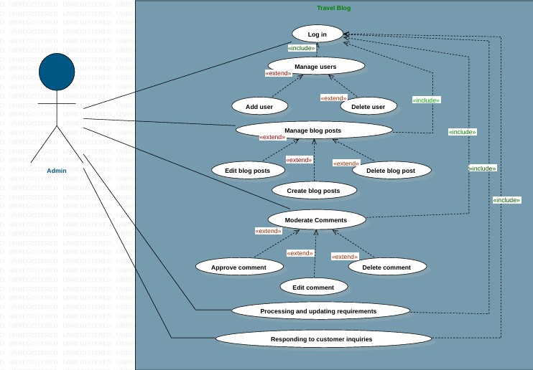

**Figure3.1:UsescasediagramforAdmin**

An active user has the ability to create an account, log in, utilize it for multiple purposes, update their account information, create posts, view blog posts, including reading comments,andinteractwithblogcontentbylikingposts,amongotherfunctionalities(refer to Figure 3.2).

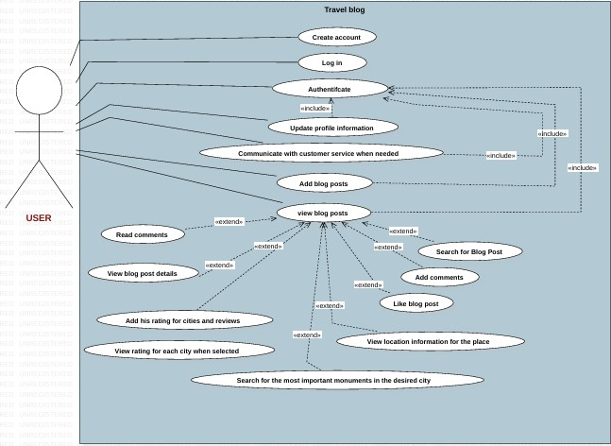

**Figure3.2:uses casediagramforUser**

* + 1. **FlowChart**

Aflowchartisagraphicalrepresentationofaprocess,system,oralgorithm.Itusesvarious symbolsandarrowstoillustratethestepsinvolvedincompletingataskorachievingagoal. Each symbolinaflowchartrepresentsadifferentactionordecisionpoint,andthearrows

indicatetheflowofcontrolordirectionoftheprocess.Thefigurebelow(Figure3.3)show the flowchart of our website.

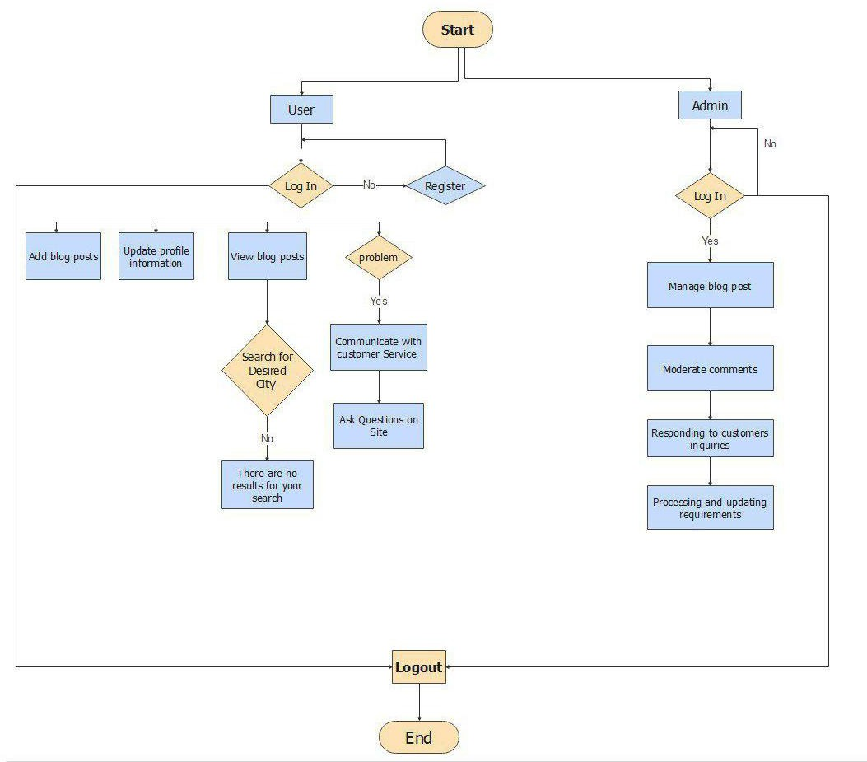

**Figure3.3: FlowChart ofourwebsite**

* 1. **DevelopmentMethodology**

Themethodologyoftheprojectisdifferentandnumerous,includingsixdifferent methodologies, the most common of which is:

* WaterfallModel,
* V-ShapedModel,
* IterativeModel,
* SpiralModel,
* BigBang Model,
* AgileModel.

Inthisproject,werelyonthewaterfall model,which isthesimplestmodeloftheproject's methodology anddependsonsixsimple andeasystepsforall teammembers andhelpsus movebetween thestepswithout any problemsespeciallyfor peoplewhodo nothavehigh experience in developing and managing projects. The Figure 3.4describes the phases of the iterative waterfall.

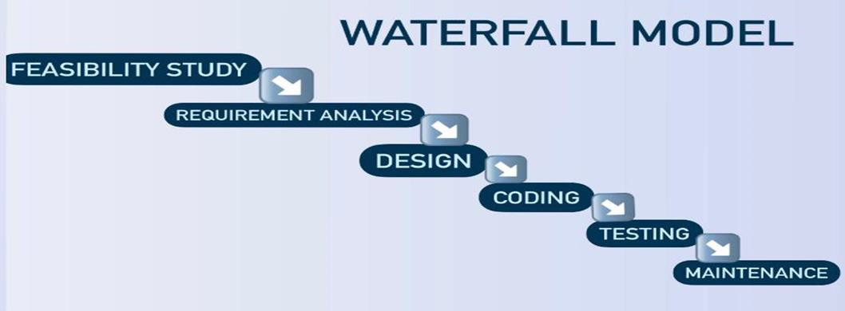

**Figure 3.4:AdvancedWaterfall model**

* 1. **Summary**

Inthischapterwestudied anddetermined theanalysisofthissystembyspecifying the functional and non-functional requirements.

**Chapter4:System Design**

* 1. **Introduction**

This chapter presents the system design considering the main dimensions of our proposed system. Further, it discusses the various aspects of system design, including object- oriented, Database design, and user interface design.

* 1. **ObjectOrientedDesign**

## Class Diagram

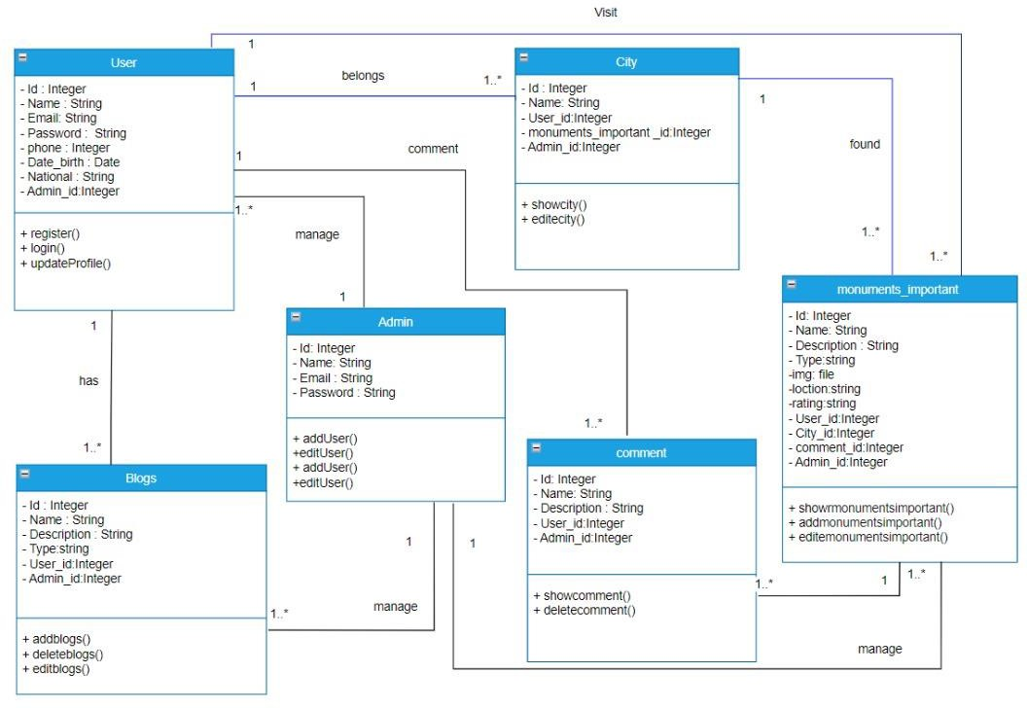

**Figure 4. 1: Class Diagram**

## SequenceDiagram

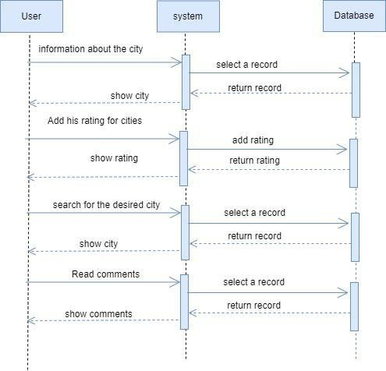

**Figure4.2:SequenceDiagramforviewBlog**

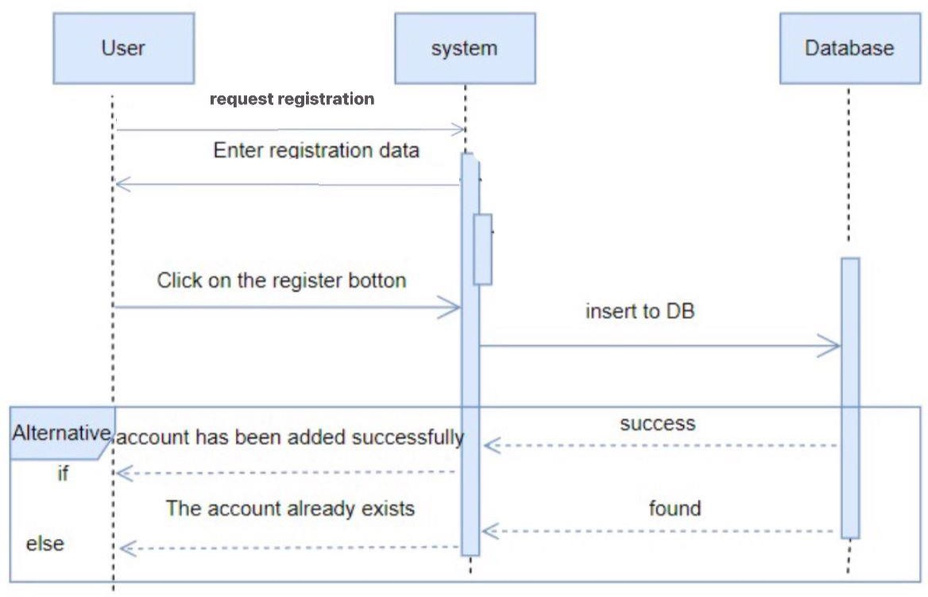

**Figure4.3:Sequencediagramforcreate account.**

**Chapter 4: System Design**

4.1**Introduction**

This chapter presents the complete system design and discusses the most important aspects including architectural design, database design, user interface design, and object-oriented design.

**4.2****Architectural design**

We will use a **three-tier architecture** in this project, which consists of three main levels: **the user, the system, and the database**.

**.4.21 The three levels:**

1. **User**: Represents the interface through which the user interacts with the system Using ( HTML, CSS, Javascript )

2. **System**: Comprises the application and processes that manage the interaction between the user and the data Using ( PHP )

3. **Database**: Responsible for storing and managing data Using MySQL

**4.3 Object Oriented Design**

4.3.1 ………………………….

4.3.2 …………………………..

4.3.3 ………………………..

**4.4.3 Activity Diagram**

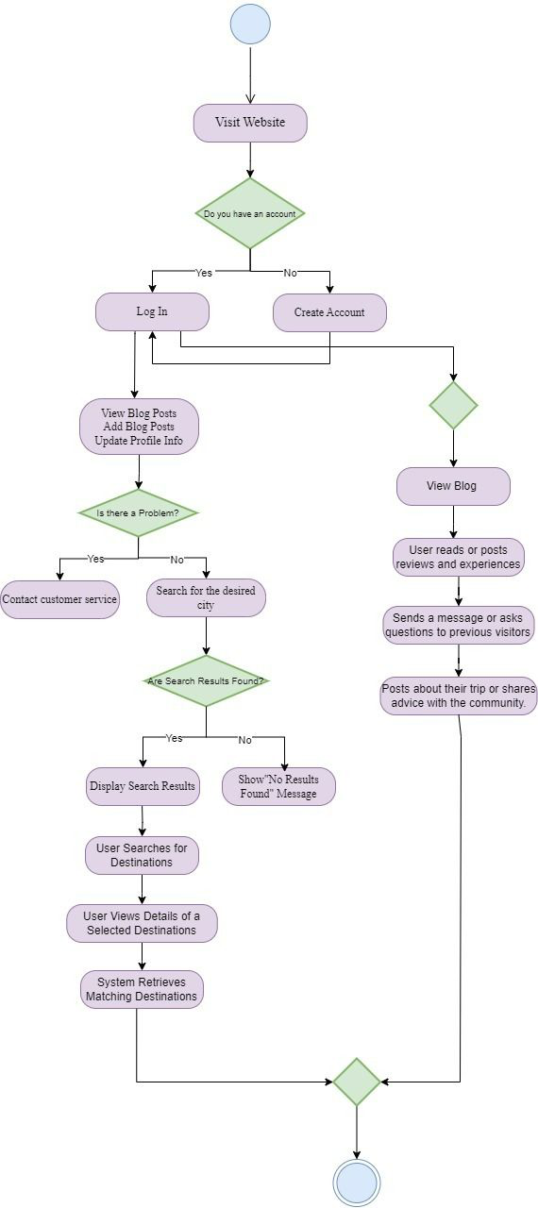

**4.4Database Design**

**\* User**

Table 4.1:User table

|  |  |  |
| --- | --- | --- |
| **Attribute** | **Type** | **Rule** |
| **User_ id** | **integer** | **PK** |
| **User_ name** | **string** |  |
| **User_ Email** | **string** |  |
| **User_ password** | **string** |  |
| **User_ phone** | **integer** |  |
| **User_ Date-birth** | **Date** |  |
| **User_ National** | **string** |  |
| **User_Admin-id** | **integer** |  |

**\*Admin**

Table 4.2: Admin table

|  |  |  |
| --- | --- | --- |
| **Attribute** | **Type** | **Rule** |
| **Admin _id** | **integer** | **PK** |
| **Admin _Name** | **string** |  |
| **Admin _Email** | **string** |  |
| **Admin _password** | **string** |  |

**\* Blogs**

Table 4.3:Blog table

|  |  |  |
| --- | --- | --- |
| **Attribute** | **Type** | **Rule** |
| **Blog _id** | **integer** | **PK** |
| **Blog _ Name** | **string** |  |
| **Blog_ Description** | **string** |  |
| **Bog _ Type** | **string** |  |
| **Blog _ Admin _id** | **integer** |  |
| **Blog _User _id** | **integer** |  |

**\* Comment**

Table 4.4:Comment table

|  |  |  |
| --- | --- | --- |
| **Attribute** | **Type** | **Rule** |
| **Comment_Id** | **integer** | **PK** |
| **Comment_Name** | **string** |  |
| **Comment_Description** | **string** |  |
| **Comment_User_id** | **Integer** |  |
| **Comment_Admin_id** | **Integer** |  |

**\* City**

Table 4.5:City table

|  |  |  |
| --- | --- | --- |
| **Attribute** | **Type** | **Rule** |
| **city _Id** | **integer** | **PK** |
| **city _ Name** | **string** |  |
| **City_User_Id** | **integer** |  |
| **City_Monuments_Important_Id** | **integer** |  |
| **city _ Admin _Id** | **integer** |  |
| **city _Admin_Id** | **integer** |  |

**\* Monuments_Imporant**

Table 4.6:monuments_imporant table

|  |  |  |
| --- | --- | --- |
| **Attribute** | **Type** | **Rule** |
| **Monuments_Important_Id** | **integer** | **PK** |
| **Monuments _ Important_Name** | **string** |  |
| **Monuments_Important_Description** | **string** |  |
| **Monuments _Imprtant_ Type** | **string** |  |
| **Monuments_ Imprtant_Img** | **file** |  |
| **Monuments_ Imprtant_Loction** | **string** |  |
| **Monuments_ Imprtant_Rating** | **string** |  |
| **Monuments_ Imprtant_User_Id** | **integer** |  |
| **Monuments_ Imprtant_City_Id** | **integer** |  |
| **Monuments_Imprtant_Comment_Id** | **integer** |  |
| **Monuments_ Imprtant_Admin_Id** | **integer** |  |

# References

1. [https://www.thedollztertravels.com/.](https://www.thedollztertravels.com/)
2. <https://safar22.com/>
3. <https://wanderlusters.com/>
4. <https://travelhero.app/blog/>